**Name – Parag Gattani**

Program No. – 02

Program Title – Traffic Controller

**AIM**

Traffic Signal Simulator.

**HARDWARES REQUIRED**

* Arduino Board
* LEDs
* Breadboard

**CIRCUIT DIAGRAM**

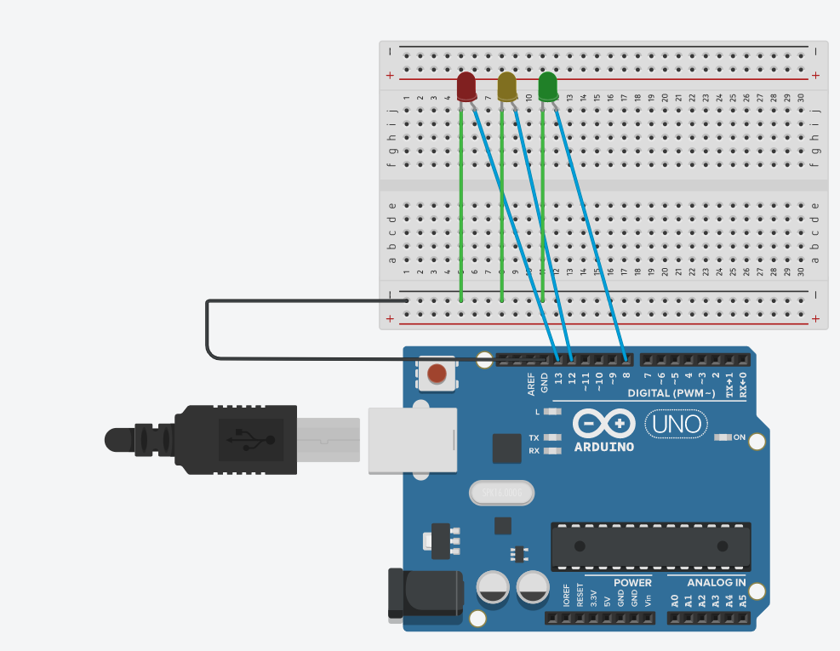

**WRITE-UP**

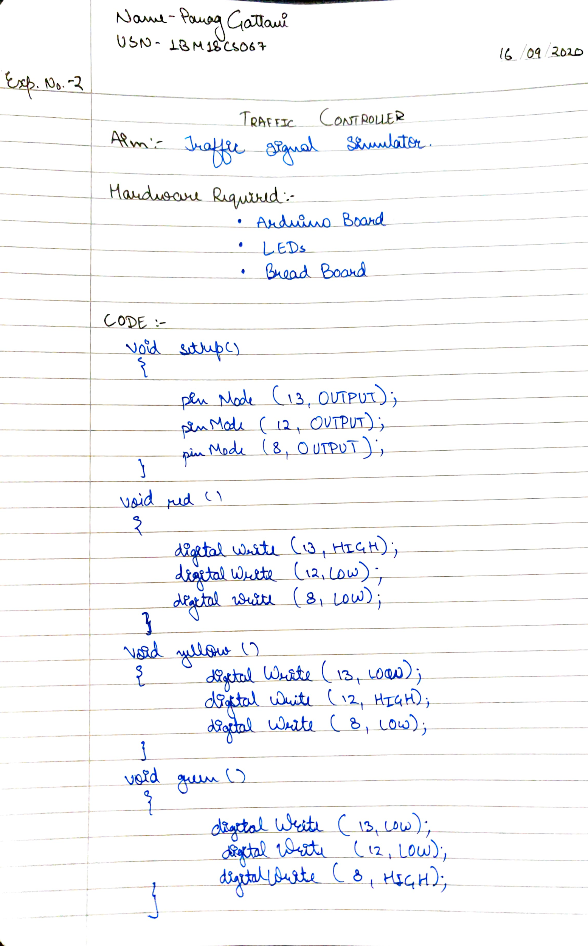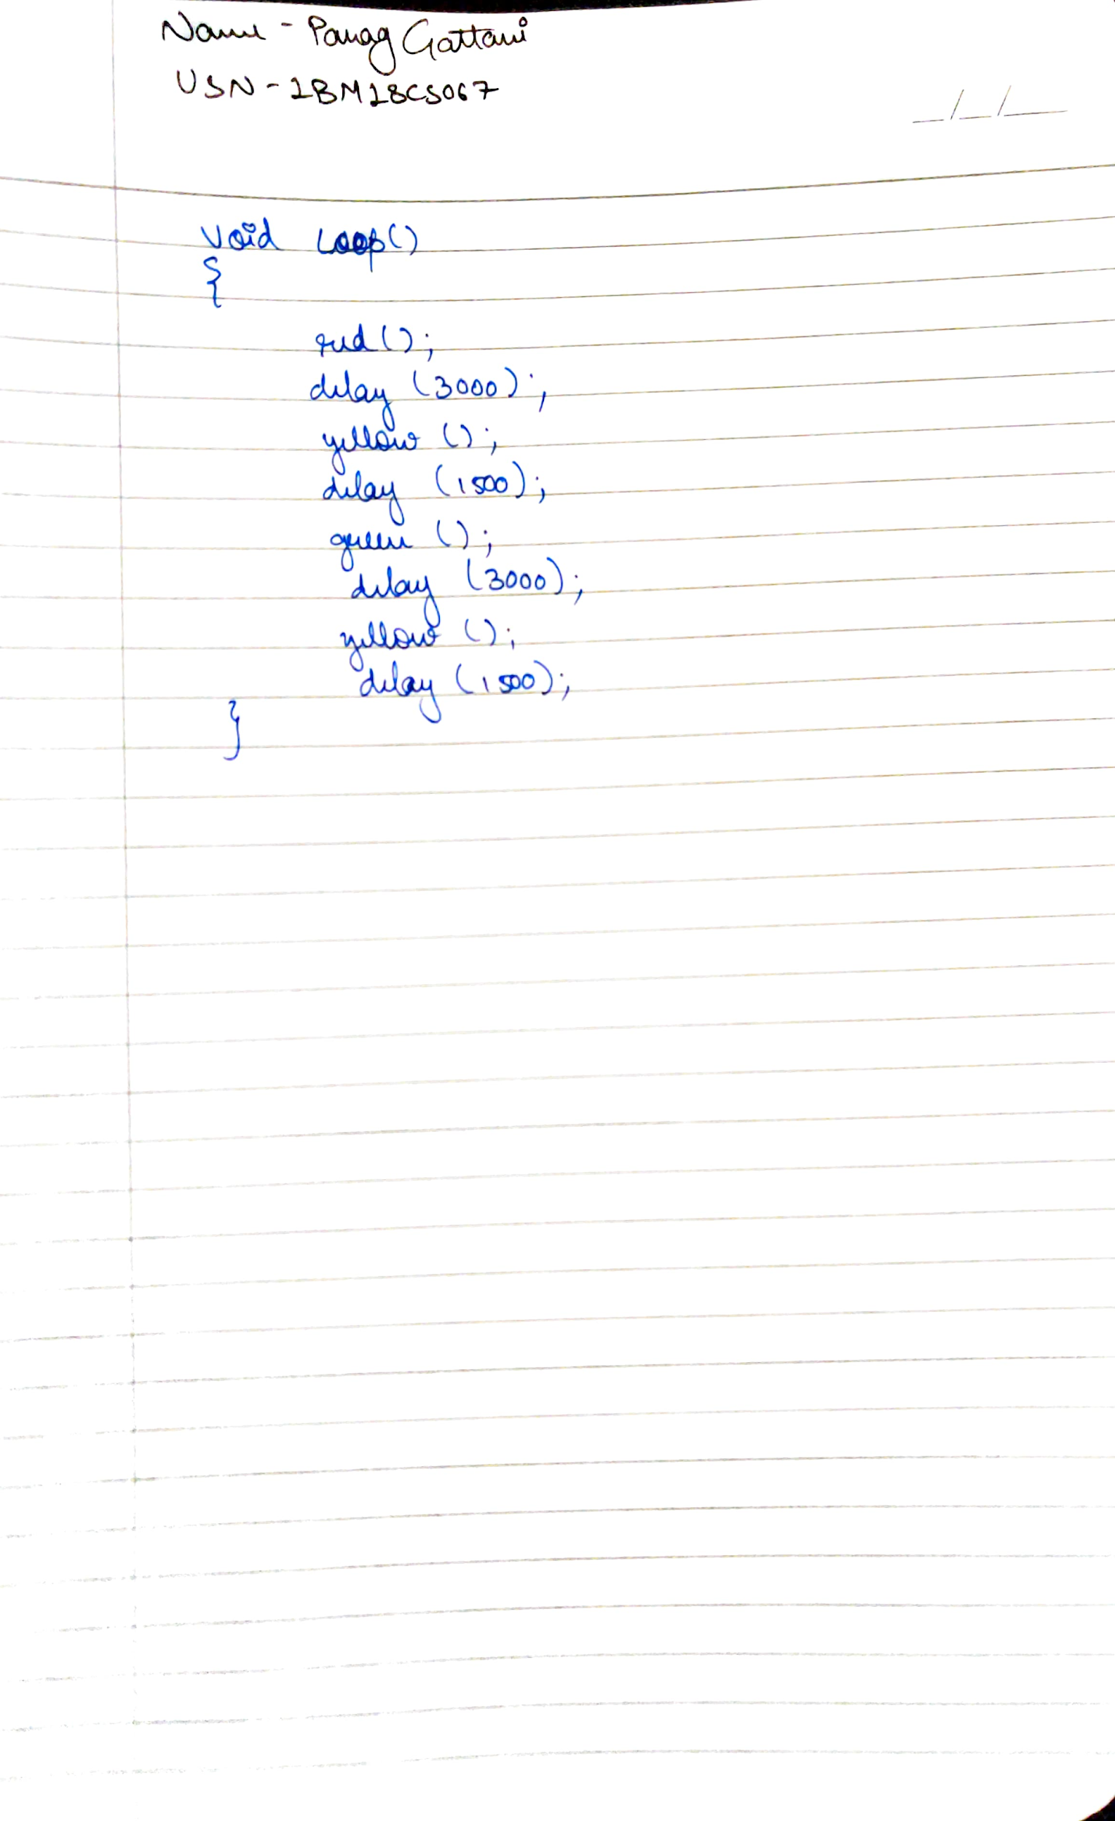

**CODE**

void setup()

{

pinMode(13, OUTPUT);

pinMode(12,OUTPUT);

pinMode(8,OUTPUT);

}

void red()

{

digitalWrite(13, HIGH);

digitalWrite(12,LOW);

digitalWrite(8,LOW);

}

void yellow()

{

digitalWrite(13, LOW);

digitalWrite(12,HIGH);

digitalWrite(8,LOW);

}

void green()

{

digitalWrite(13, LOW);

digitalWrite(12,LOW);

digitalWrite(8,HIGH);

}

void loop()

{

red();

delay(3000);

yellow();

delay(1500);

green();

delay(3000);

yellow();

delay(1500);

}

**OUTPUT**

All the three LEDs blink one after the other at an interval of 1000ms.